Required Capstone Checkpoint 2.1: Retrieval Strategy Design and Baseline Implementation

Directions

You will continue working with the same dataset and scenario you selected for your capstone checkpoint in Module 1. In this activity, you will design and implement a baseline retrieval system that supports the types of queries required for your scenario.

Download this worksheet and save a copy to your device before you begin working. Type your responses directly into the document, save your completed work, and upload the finished file when you are ready to submit.

Use this worksheet to:
- Document your retrieval approach
- Capture representative retrieval queries and results
- Provide evidence that your retrieval system is functioning
- Observe how retrieval performance changes across different query types
- Reflect on where the retrieval approach performs well and where it struggles

1. Selected Scenario and Retrieval Approach
- Identify your chosen capstone scenario.
- Describe the retrieval approach you implemented (keyword-based, semantic, or hybrid).
- Briefly explain why this retrieval approach is appropriate for your dataset and query types.
- Describe any trade-offs you considered when selecting this approach
Scenario
☐ Research Paper Navigator
x Wikipedia Retrieval Engine
Retrieval approach used, brief explanation, and description of trade-offs considered
I used a hybrid retrieval approach, combining vector similarity search and BM25 keyword retrieval.

The primary trade-off considered was the balance between semantic understanding and lexical precision. Relying solely on vector retrieval may miss documents that contain highly specific terms, formulas, or names that are important to the user's intent. Conversely, BM25 may fail when relevant information is expressed using different wording or synonyms. By combining both approaches, the system benefits from the strengths of each method while mitigating their individual weaknesses.
This choice is especially appropriate for a Wikipedia-based retrieval system, where users may submit both broad, natural-language questions (for example, "How did the Roman Empire decline?") and highly specific searches (for example, "Kolmogorov-enthropy" or simialr scientific terminology). A hybrid approach therefore provides more robust retrieval performance across a wider range of query types.

2. Baseline Retrieval System Evidence
- Provide evidence that your retrieval system was implemented and tested.
- Evidence may include screenshots, logs, outputs, notebook examples, code snippets, or brief descriptions showing that retrieval queries were executed successfully.
Evidence of retrieval system implementation and testing
I had 3 main scenarios: 1 without the weight system on a small number of articles, and 2 with the weighting implemented (bm25 – 60%, vector 40 %, then opposite) first on a small number of articles, then on all the 2419 wikipedia aricles. The below are examples from the outputs:
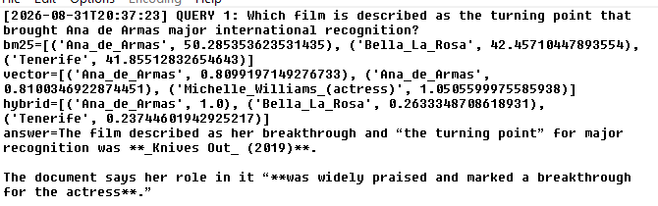
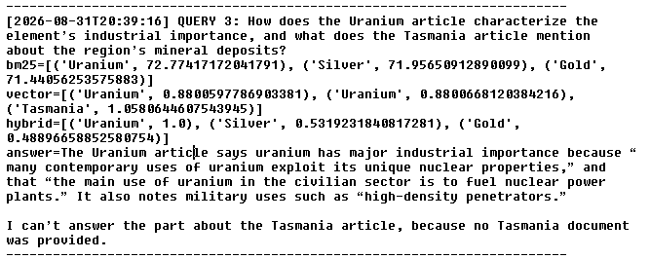
An interesting part is when ran on smaller number of articles Query 4 produced a much better output:
On all articles: 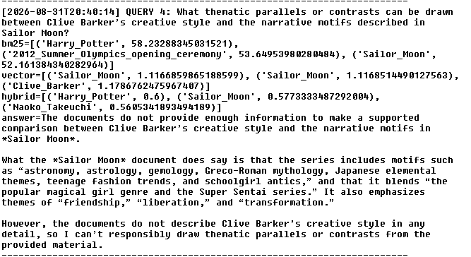
On a smaller batch:
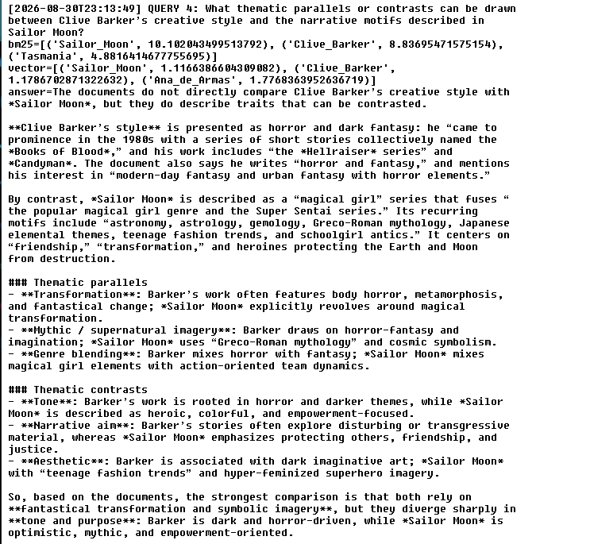

3. Representative Queries and Retrieved Results
- Provide three to five representative queries relevant to your scenario.
- Include the retrieved results for each query.
- Focus on showing how the retrieval system behaves across different types of information needs. Where possible, include a mix of precise, conceptual, or broader exploratory queries.
Query 1
Query: What creature is portrayed as a defining symbol of Tasmania’s natural environment?
Retrieved results: The creature portrayed as a defining symbol of Tasmania’s natural environment is the **Tasmanian devil**. The Tasmania document lists it as the state’s mammal symbol: **“Mammal Tasmanian devil (Sarcophilus harrisii)
Observations:
What worked well? What limitations, challenges, or unexpected retrieval behaviors did you observe?
BM25, vector, and hybrid all ranked the Tasmania document first. This shows that the query (“defining symbol of Tasmania’s natural environment”) contained enough lexical and semantic cues for all retrieval modes to converge on the correct source.
BM25 surfaced Leviathan (Hobbes book) and Victoria (state) as high-scoring factors. While The vector model ranked “Procellariiformes”, which are a type of sea birds highly.
This query can be considered a strong example of why hybrid retrieval is valuable as it stabilizes the weaknesses of each individual method while still surfacing the correct document with high confidence.

Query 2
Query: How does the Uranium article characterize the element’s industrial importance, and what does the Tasmania article mention about the region’s mineral deposits?
Retrieved results: The Uranium article says uranium has major industrial importance because “many contemporary uses of uranium exploit its unique nuclear properties,” and that “the main use of uranium in the civilian sector is to fuel nuclear power plants.” It also notes military uses such as “high-density penetrators.”
I can’t answer the part about the Tasmania article, because no Tasmania document was provided.
Observations:
The vector model placed Tasmania in the top-3, even though the query’s first half is about Uranium. This indicates the embedding model understood that “mineral deposits” semantically relates to geology, mining, and natural resources — topics present in the Tasmania article.
The system correctly quoted the Uranium document as well.
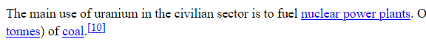
The query requires information from two documents: Uranium and Tasmania. But only the Uranium document was available. The system correctly refused to hallucinate and stated it couldn’t answer the Tasmania portion, although the expression is not accurate, as the document is available, it just does not contain any mention of Uranium. But still it shows that hybrid retrieval cannot compensate for missing documents.

Query 3
Query: How does Sailor Moon contribute to the broader tradition of magical‑hero storytelling, based on its article?
Retrieved results: According to the article, *Sailor Moon* helped reshape and strengthen magical-hero storytelling by blending familiar heroic-team and transformation elements into the magical girl genre. It says the series is “a fusion of the popular magical girl genre and the Super Sentai series,” and that it uses a team of heroines who “transform into” heroes to battle evil.
The article also says it was “widely credited with reinvigorating the magical girl genre,” and that after its success “many similar magical girl series” appeared. So, based on the article, *Sailor Moon* contributes by popularizing a team-based, transformation-driven model of magical-hero storytelling and by helping inspire later works in the genre.
Observations:
BM25 ranked Sailor Moon first with a high score, which was expected considering the word usage of “Sailor Moon”, “magical-hero storytelling” and “article” that directly point to the Sailor Moon document’s vocabulary. The vector model also placed Sailor Moon at the top. This shows that the embedding model correctly interpreted the query’s semantic intent — understanding that “magical-hero storytelling” relates to genre influence, transformation motifs, and heroic team dynamics described in the article. Hybrid scoring gave Sailor Moon a perfect 1.0, confirming that combining the methods produced a confident, unambiguous match.

Optional Additional Queries

4. Retrieval Performance Reflection
- Reflect on where your retrieval approach performs well and where it struggles.
- Consider how different query types affect retrieval quality, relevance, flexibility, or precision.
Retrieval strengths
Which types of queries did your retrieval strategy handle most effectively? What aspects of the approach contributed to these results?
My system handled concrete, single-topic factual queries most effectively — especially those where the answer lives cleanly inside one document and the query wording still overlaps conceptually with that document’s content. The patterns are consistent across Query 1, 2, and 5.
Hybrid retrieval consistently gave the correct document a 1.0 score for these queries, as bm25 provides strong lexical grounding, while vector retrieval provides semantic alignment. Their combined method reduces the chances of false positives or misfires.

Retrieval limitations or challenges
Which queries were more difficult for the retrieval system? What limitations or trade-offs became apparent?
The ones, where cross-document comparison were required (Query 3 and 4). The query required 2 documents, but only one was available, or only one contained the required data.
Query 4 uses high-level conceptual language ans connects two highly unrelated domains (horror literature vs. anime magical-girl anime). Bm25 immediately jumped to Harry Potter, giving it the highest score as the similarity in lexical terms is evident.
But it is also interesting to note, that when less source was provided to the model it gave a radically different answer, therefore I believe the result was highly influenced by noise from the bm25 which carried over for the end result.

Patterns observed across different query types
What patterns did you observe when comparing retrieval performance across different query types? How did these observations influence your understanding of the strengths and limitations of your chosen retrieval strategy?
My retrieval strategy excels at concrete, single-topic factual queries, but then becomes unstable when queries are cross-document, abstract or comparative across unrelated domains.
It is clear, that when bm25 and vector retrieval align, hybrid scoring is extremely stable. This happens in single-topic factual queries. The hybrid model can inherit noise from both side though, but bm25 can unbalance the scale more when it is “confidently wrong”.

5. Retrieval Strategy Reflection
If you were continuing to improve this system, would you keep the same retrieval approach or make changes? Explain your reasoning.
Reflection
First, I'd like to highlight that the model itself is extremely slow when it’s reading the 2400+ html files, so first step would be to make it faster.
The hybrid retrieval approach is definitely worth keeping, as it answered factual queries (Ana de Armas, Tasmani, Sailor Moon), and when both signals aligned I got stable answers. I believe what could improve my system is how the queries are processed. There could be a sort of classifier, that can detect the nature of the queries and categorize them as factual, comparative or “multi document”. It could dynamically change the weight system for bm25 and vector or modify the top-k approach for relevant documents.

Supporting Materials
Additional Evidence (Optional):
If needed, include any additional screenshots, output excerpts, or code snippets that support your responses above. No additional files or repository link are required for this checkpoint.

End of Required Capstone Checkpoint 2.1
Return to the assignment page in the learning platform to upload and submit your completed capstone checkpoint and complete any remaining items in this module.

